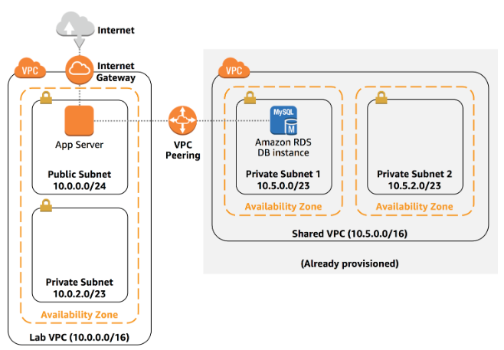

Create a Lab VPC (10.0.0.0/16) ; goto action edit DNS hostname >> enable>> save (to assign friendly DNS to EC2)
Create Public Subnet (10.0.0.0/24); Action>>modify auto-assign IP settings >>auto assign IPv4>>enable
Create Private Subnet (10.0.2.0/23)
Create Internet Gateway : Lab IGW and attach it to Lab VPC
Configure Route Table:
Rename the default/global route table as Private Route Table
Create Public Route Table in Lab VPC
Edit route >>Add route >>Destination: 0.0.0.0/0 >>target : Lab IGW>>subnet association : public subnet.
Create SG : App SG; inbound rule; type : http; source : anywhere

Create an IAM role : App inventory role
{
"Version": "2012-10-17",
"Statement": [
{
"Action": "ssm:*",
"Resource": "arn:aws:ssm:*:*:parameter/inventory-app/*",
"Effect": "Allow"
}
]
}

Create EC2 with app-inventory role ;user data and app-sg
#!/bin/bash
# Install Apache Web Server and PHP
yum install -y httpd mysql
amazon-linux-extras install -y php7.2
# Download Lab files
wget https://hugonet.s3-us-west-2.amazonaws.com/Deploying+a+Web+Application+on+AWS/inventory-app.zip
unzip inventory-app.zip -d /var/www/html/
# Download and install the AWS SDK for PHP
wget https://hugonet.s3-us-west-2.amazonaws.com/Deploying+a+Web+Application+on+AWS/aws.zip
unzip aws -d /var/www/html
# Turn on web server
chkconfig httpd on
service httpd start
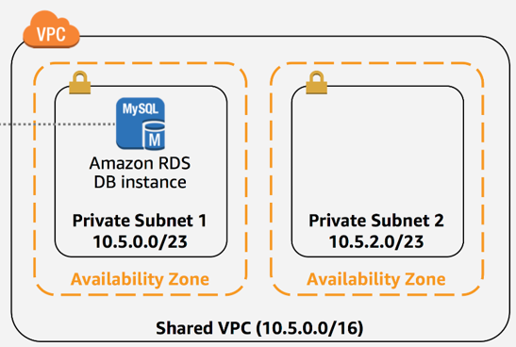
Create Shared VPC (10.5.0.0/16)
Private Subnet 1 (10.5.0.0/23) in AZ-1 & Private Subnet 2 (10.5.2.0/23) in AZ-2
Create DB-SG in shared vpc ; Type : MySql Aurora ; source : VPC 10.0.0.0/24
Create a MySql DB (free tier) in Private subnet 1
DB instance identifier : inventory-db
Master username : master
Master password : lab-password
Confirm password : lab-password
Instance size : t2.micro
Burstable class : db.t2.micro
Connectivity : Shared-VPC
Additional connectivity configuration : existing vpc security group : DB-SG
Additional configuration : initial DB name : inventory ; go with all the default values
Create DB

Create peering
Create peering connection
Name tag : Lab-Peer
VPC requestor : Lab-VPC
VPC Acceptor : Shared-VPC
Create VPC
Select Lab-peer >>Action>>accept request
Configure route table :
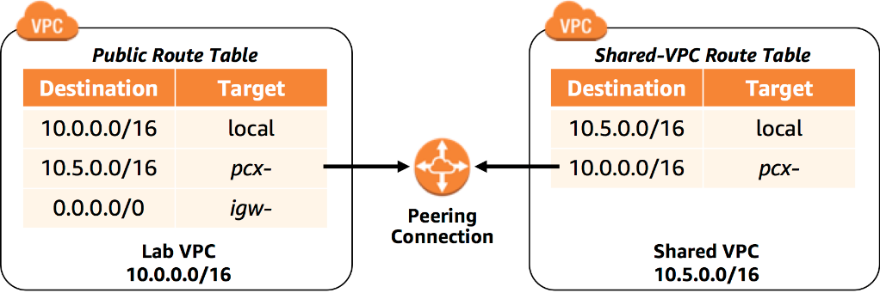
Public route table (lab vpc) >>add route >>destination : 10.5.0.0/16 target : peer-lab
Shared VPC route table >>add route >>destination : 10.0.0.0/16 ; target : peer lab

- Endpoint: Paste the Endpoint from db
- Database:
- Username:
- Password:

